19. Display Dimensions/Shape and Column Names
import pandas as pd
df = pd.read_csv("drinks.csv")
print("Shape of the dataset:")
print(df.shape)
print("\nNumber of rows:", df.shape[0])
print("Number of columns:", df.shape[1])
print("\nColumn names:")
print(df.columns.tolist())
OUTPUT:
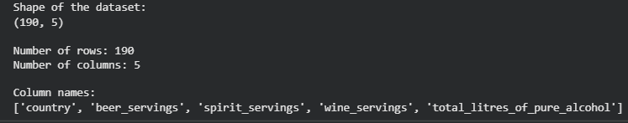

20.the Index of a Given Substring in a DataFrame Column
import pandas as pd
data = {
'name': ['John Smith', 'Alice Brown', 'David John', 'Mary Wilson']
}
df = pd.DataFrame(data)
substring = "John"
df['index'] = df['name'].str.find(substring)
print(df)
OUTPUT:
